2. CREATE A SIMPLE CLOUD SOFTWARE APPLICATION FOR FLIGHT RESERVATION SYSTEM USING ANY CLOUD SERVICE PROVIDER TO DEMONSTRATE SAAS.
DATE: 17.11.2025
DAY: MONDAY
AIM:
To create a simple cloud software application for flight reservation system using any cloud service provider to demonstrate saas.

PROCEDURE:
step1: Go to zoho.com.
step 2: Log into the zoho.com.
step 3: Select one application step.
step4: Enter application name as flight reservation system.
step 5: Created new application flight reservation system.
step 6: Select one form
step 7: The software has been created.

IMPLEMENTATION:
1.logic form
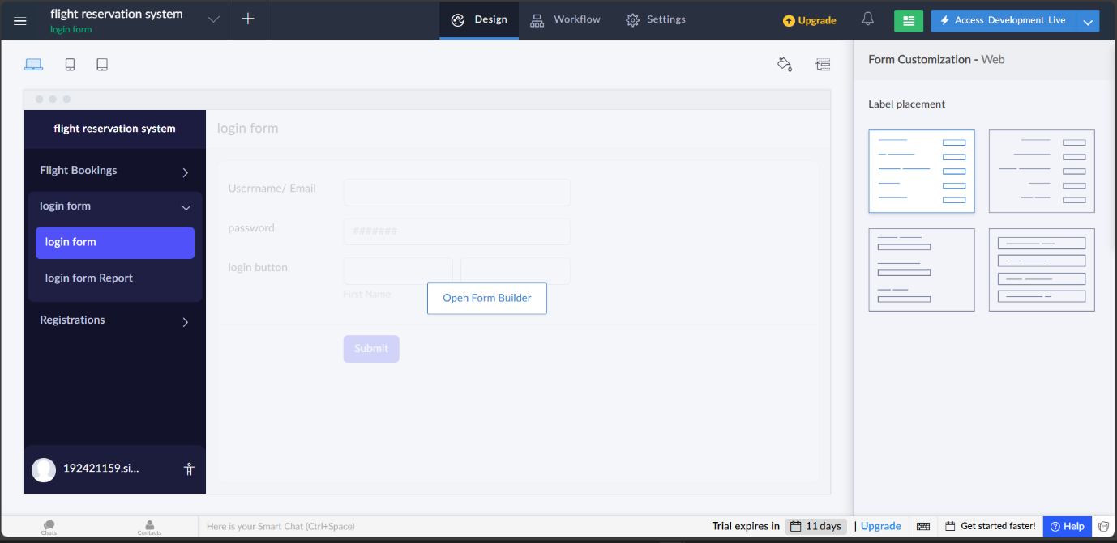

2.Flight Booking
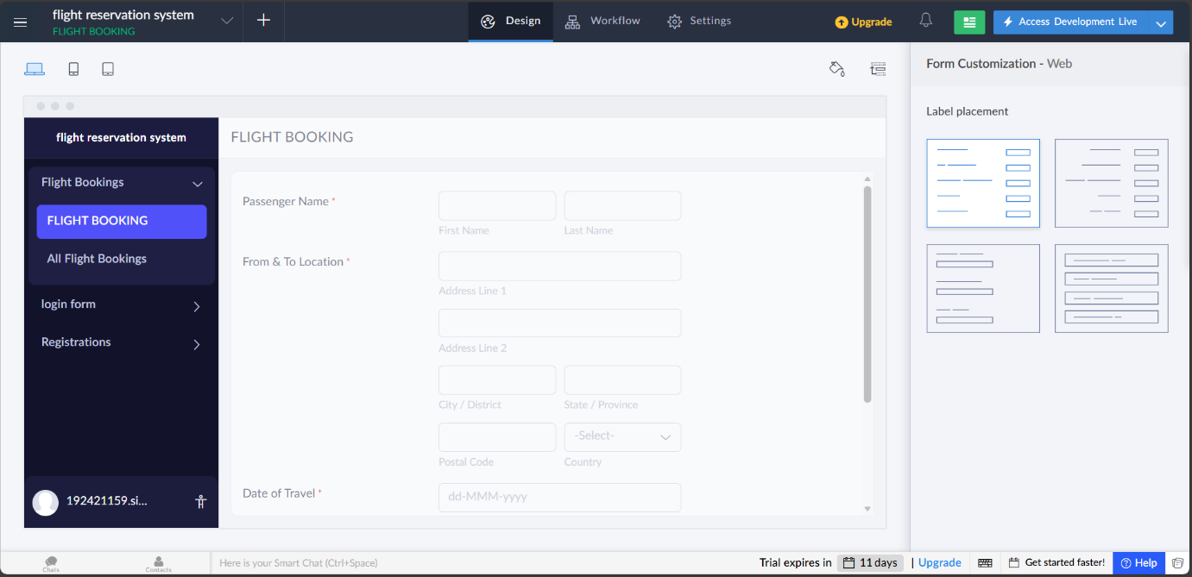

3.Registration Form
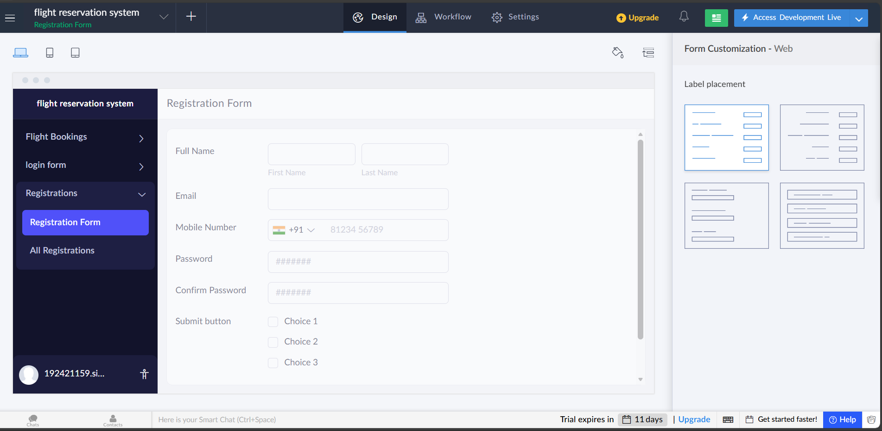
RESULT:
Successfully Created a simple cloud software application for FLIGHT RESERVATION SYSTEM.

